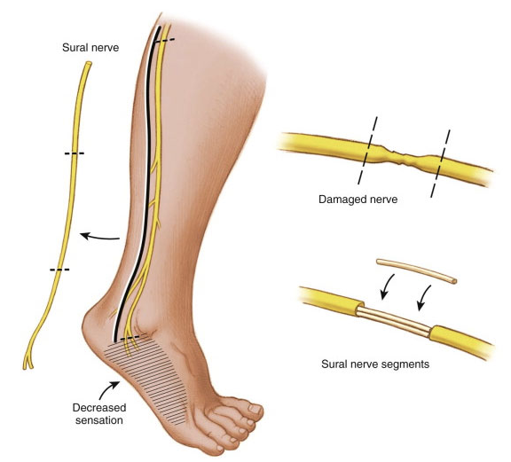

**Figure 1:** Nerve grafting. (Reproduced with permission from the Mayo Foundation for Medical Education and Research)

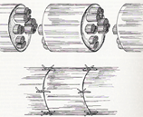

**Figure 2:** Trunk graft.

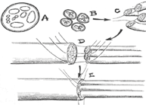

**Figure 3:** Cable graft [11].

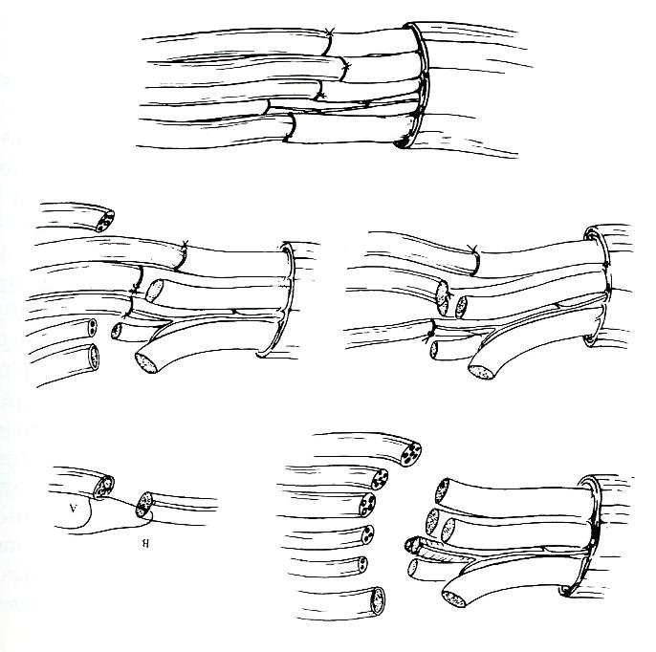

**Figure 4:** Interfascicular graft.

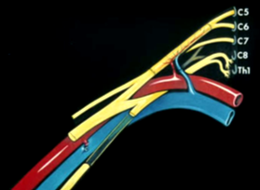

**Figure 5:** Free Vascularized graft.

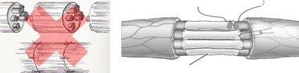

**Figure 6:** Diameter of Graft.

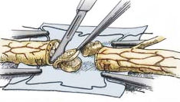

**Figure 7:** Preparation of the host nerve [12].

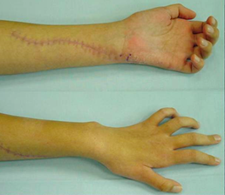

**Figure 8:** 4 months later there was complete absence of sensory and motor function of the ulnar nerve.

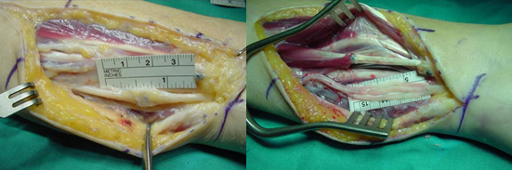

**Figure 9:** The ulnar nerve was explored, a large neuroma at the site of suture was found, which was resected and the defect bridged with three nerve grafts.

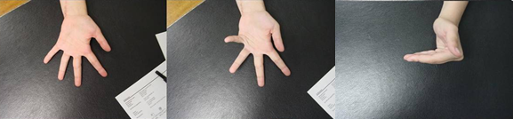

**Figure 10:** The postoperative result after one year was restoration of sensation and function of the interosseous muscles.