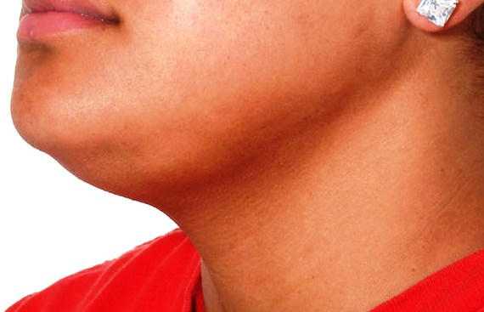

**Figure 1:** Left submandibular swelling-Left plunging ranula.

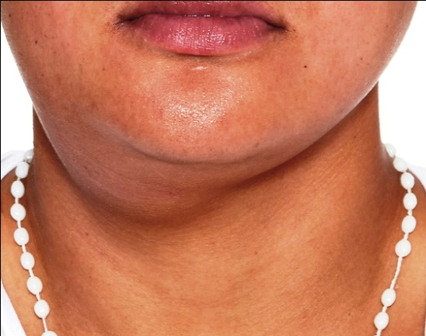

**Figure 2:** Right submandibular swelling-Right plunging ranula.

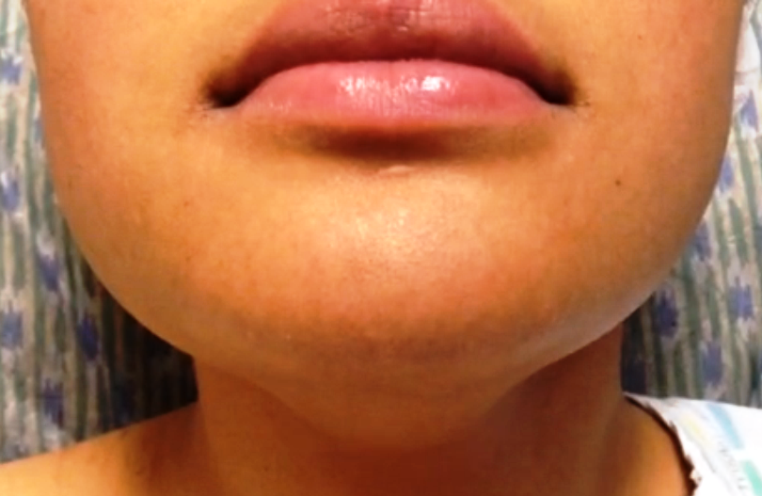

**Figure 3:** Normal floor of mouth.

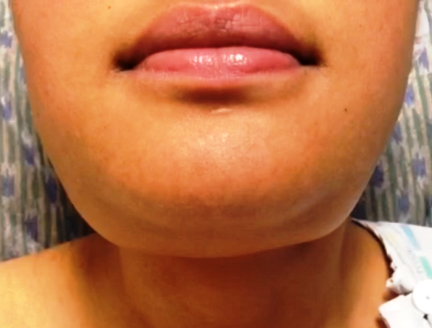

**Figure 4:** No visible submandibular regions swelling.