**A strategy to overcome under-reporting issues of voluntary medication error reporting system: computerized prescriber order entry as an example**

**First author name1 and second author name2**

1Department, University, Country  
2Department, University, Country

**Correspondence: N**ame, Department, University, Full addressing details, Country, Tel +123 4 56789, Email [XXX@mail.com](mailto:XXX@mail.com)

1. **Abstract**

**Background:** Medical error reporting systems have been in place for decades, with the hope that the collected reports would help us understand the nature of errors and prevent similar errors from occurring in the future. Among the various types of reporting systems, a voluntary system leaves the decision about whether to report a detected error or not to healthcare providers. Naturally, not every detected error has been reported, and we call such a phenomenon under-reporting. The level of under-reporting varies across reporters and organizations, which has prohibited us from analyzing the data and utilizing the results with satisfactory validity. The current study tried to show how to overcome this issue, using the effectiveness of a computerized prescriber order entry (CPOE) system as an example. Since CPOE is designed to catch the prescribing error, we first calculated the ratio between the odds of prescribing error reaching the patient and that of administering errors seemingly unrelated to the prescribing phase. We then compared this ratio between hospitals with CPOE and without CPOE. With this methodology, combined with adding a random intercept to control for hospital-level clustering of medication errors, we could effectively handle the varying degrees of reporting levels across hospitals, achieving a solid comparison of the effectiveness of CPOE between hospitals with and without CPOE. The final results showed that the odds of an error being caught before reaching the patient was 4.63 times higher in the prescribing phase of the medication use process among hospitals using CPOE than among hospitals without CPOE. We believe the methodology used in this study can be applied to many other topics in patient safety studies using data from voluntary medical error reports.

1. **Keywords:** voluntary medical error reporting, computerized prescriber order entry, cope, under-reporting, reporting and learning systems
2. **Introduction**

Thousands of victims of medical errors exist in the clinical realm.1,2 Most of these types of errors have occurred in the past, meaning the same modality is occurring again and again, harming our beloved patients and certainly discouraging healthcare professionals. Yet the flipside of the coin is that we can prevent the repeatedly occurring errors only if we have information on the mechanism—namely, how the errors occur. To address this issue, many error reporting systems have been developed and are currently in operation.1,2 Each of these systems has various fields of interest; some collect reports from all medical errors whereas others focus on a specific part of medical care, such as surgical events or intensive care units.

The modus operandi varies extensively between completely mandatory and completely voluntary as the extremes of the continuum. Simply put, mandatory systems are mainly designed for severe events like patient deaths or hospital-acquired infection; quite often, such information is tied to reimbursement systems. On the other hand, voluntary medical error reporting systems do not mandate healthcare professionals to report errors they have detected. This voluntary nature is frequently linked to the need for anonymity among healthcare organizations and individual practitioners reporting their errors, so that they are free from the fear of reprimand. However, the price of such protection of reporters cannot be ignored; one outcome is under-reporting, which has not yet been clearly resolved, as depicted in Figure 1. When not every detected error is reported, we do not have clear information for the detecting-to-reporting ratio, which must vary across organizations or even among individual practitioners. This results in any comparison of the results across departments or organizations being unstable and, quite honestly, impossible. This reporting behavior, known to be related to organizational culture, has been measured in safety culture survey questionnaires,3-6 yet such culture data have not been successfully utilized to adjust for the difference between detection and reporting.

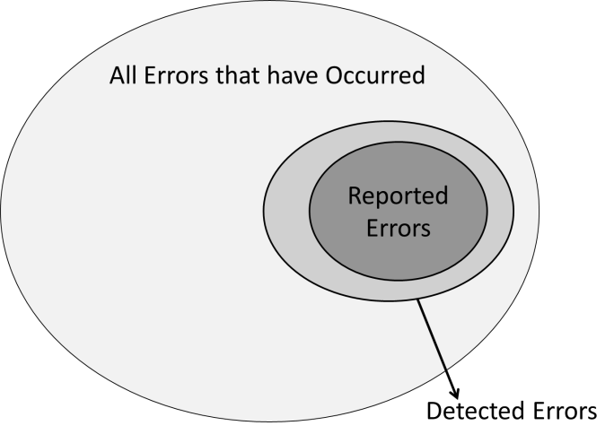

**Figure 1:** Relationship between detected errors and reported errors.

To crack this nemesis of under-reporting, we chose one of the largest reporting system’s datasets, called MEDMARX. This national (US) voluntary reporting system collects specifically medication errors and has collected more than a million cases thus far.7 We chose to use MEDMARX not just because of statisticians’ need for huge and complex data, but also because—among the various types of medical errors tracked—medication errors account for a large proportion, which is easily understandable given that medication is the oldest and most frequently used venue of medical treatment.8-14

1. **Methods**

The premise of a prescribing error causing harm to a patient is that the error must reach the patient. CPOE is supposed to catch errors specifically in the prescribing phase; thus, if CPOE plays its part as expected, errors should be less likely to reach the patient. Yet CPOE is not supposed to influence errors in other phases of medication use process, such as administering. Therefore, we consider administering error reports as an anchor to adjust each hospital’s reporting tendency or culture. This means that we may not be able to directly quantify how well CPOE catches prescribing errors before reaching the patient, but we can compare the ratio of prescribing error reaching the patients between hospitals with and without CPOE after adjusting for the same ratio of administering error as reference, albeit reporting culture varies across hospitals. Figure 3 help readers understand this approach.14-21



1. **Results**

**Characteristics of MEDMARX participating hospitals and collected error reports**

Table 1 describes organization-level characteristics that were plugged into the previously discussed formula as covariates except for “methods available for error detection.” Note that not every hospital participated in MEDMARX for all five years (i.e., from 2003 to 2007), although the proportion of hospitals utilizing CPOE grew from 38.1% in 2003 to 50.8% in 2007. Unlike CPOE use, the proportion of healthcare facility with computer-generated medication administration records (MARs) did not vary significantly.

**Table 1** Characteristics of participating hospitals



1. **Discussion**

Medical error reporting systems have been developed to learn from defects: By analyzing multiple medical error cases, we can find patterns and even identify the mechanism describing how an error occurs. Ultimately, utilizing such information, we can redesign the healthcare process more effectively and efficiently21-36. With the hope of improving safety, healthcare professionals have submitted millions of medical error reports. Yet how thoroughly those reports were analyzed and applied to real-world improvement is in question. Indeed, most analyses were fundamentally descriptive, and the mechanism for determining how systems have broken down were beyond the scope of previous studies. Consequently, many data still have to be analyzed.

1. **Conclusion**

We know that fully understanding the methodology of this article requires not only a strong statistical background, but also knowledge about patient safety and error reporting systems. Indeed, such ideas are difficult, yet we also know that the difficulty can never justify abandoning such precious medical error datasets, which have been collected by countless healthcare professionals through their immeasurable time and efforts. Obviously, the methodology we introduced is not a panacea, and different topics would need a different or even brand new approach.

1. **Funding details:** About funding agency
2. **Acknowledgements:**
3. **Conflict of interests:** Authors declare that there is no conflict of interest
4. **References**

**Eg: Journal References**

Lee WC, Wung HY, Liao HH, et al. Hospital safety culture in Taiwan: a nationwide survey using Chinese version safety attitude questionnaire. *BMC Health Serv Res* 2010;10(1):234-235.

**Volume with supplement**

Lee WC, Wung HY, Liao HH. Hospital safety culture in Taiwan: a nationwide survey using Chinese version safety attitude questionnaire. *BMC Health Serv Res*. 2010;10 Suppl 1:S234–235.

**Issue with supplement**

Lee WC. Hospital safety culture in Taiwan: a nationwide survey using Chinese version safety attitude questionnaire. *BMC Health Serv Res*. 2010;10(10 Suppl 1):S234–235.

**Volume with part**

Lee WC, Wung HY. Hospital safety culture in Taiwan: a nationwide survey using Chinese version safety attitude questionnaire. *BMC Health Serv Res*. 2010;10(Pt 1):234–235.

**Issue with part**

Lee WC, Wung HY, Liao HH, et al. Hospital safety culture in Taiwan: a nationwide survey using Chinese version safety attitude questionnaire. *BMC Health Serv Res*. 2010;10(10 Pt 1):234–235.

**Issue with no volume**

Lee WC, Wung HY, Liao HH. Hospital safety culture in Taiwan: a nationwide survey using Chinese version safety attitude questionnaire. *BMC Health Serv Res*. 2010;(10):234–235.

**Book References**

**Personal author(s)**

Cohen MR, *Book title*. 3rd ed. Jones & Bartlett Learning: Edmond; 1999.

**Editor(s), compiler(s) as author**

Cohen MR, Heon JH, editors. *Book title*. 3rd ed. Edmond: Jones & Bartlett Learning; 1999.

**Author(s) and editor(s)**

Authors. *Book title*. 2nd ed. Editor names, editor. City: Publisher name; 1999.

Lee WC, Wung HY, Liao HH, et al. Book chapter name. In: Editor names, editors. *Book title.* City: Publisher name; 1999: 205.

Lee WC, Wung HY. Book chapter. In: Editor names, editors. *Book title*. place, city: publisher; 2010: 24–30.

**Organization(s) as author**

Organizing Group name. *Title*. Country: Publisher; 2010. 300 p.

Organizing Group names, Title. Place: Association; 2010 month. 64 p.

Organization names. Title. 3rd ed. place: Publisher; 1980.

**Conference proceedings**

Editor names, editors. Title of the conference paper. Conference proceeding name; 2010 oct 20-25; place, Country. Publishers city:publisher; 2010.

**Conference paper**

Author names. Title of the conference paper. In: Editor names, editors. Conference name; 2010 Aug 4-7; place, Country. Publishers city:publisher; 2010. p. 24-26.