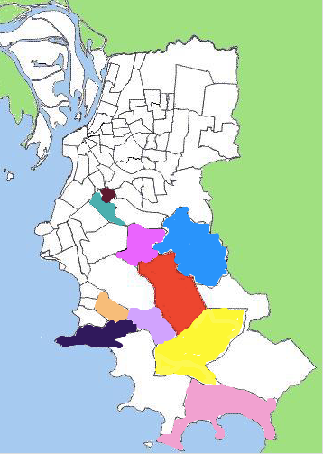

Restinga (red), Lageado (yellow), Lomba do Pinheiro (blue), Belém Velho (pink), Chapéu do Sol (light purple), Ponta Grossa (purple), Hípica (Orange), Lami (light pink), Teresópolis (green), Glória (brown)
Figure 1: Adaptation of Restinga and neighbour areas from Procempa to CA-MRSA epidemiology.

