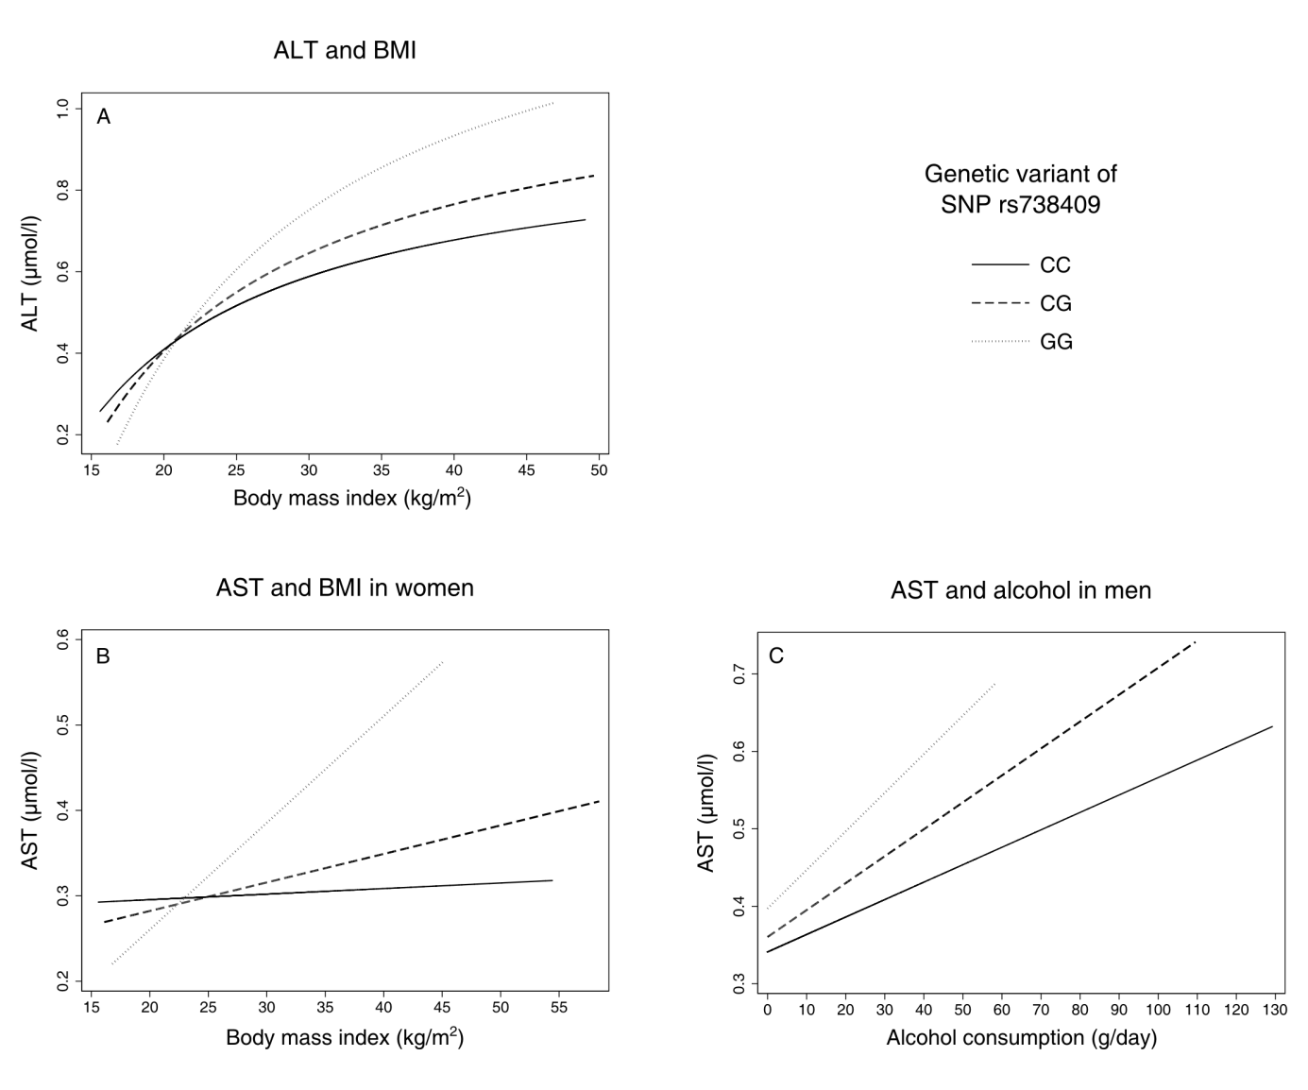

Figure 1: Predictive margins between liver-enzyme activities and environmental factors body mass index (BMI) and alcohol consumption by genetic group, adjusted for age (all models) and sex (first model, panel A); ALT: Alanine Transaminase; AST: Aspartate Transaminase.

